Mole Valley Map & Compass Foot Racing Society
Beddington Park
Tuesday 25 June 2002
Summer Series Event
Mole Valley Map & Compass Foot Racing Society
Beddington Park
Tuesday 25 June 2002
Summer Series Event

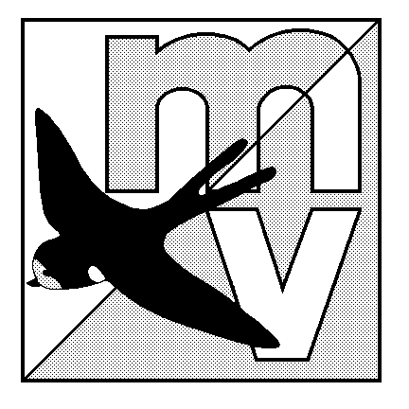

Directions: Beddington Park, near Carshalton. Car Parking at Grid Ref. TQ 288653. Turn in off London Road (A237). Event will be o-signed. Nearest station is Hackbridge.

Registration: Registration will be open from 6.15pm to 7.15pm and start times will be from 6.30pm to 7.30pm.

Fees: £2 for seniors, FREE for juniors. The event will be using control cards and punches.

Course: There will be one course, of approximately 3km and of a Light Greenish standard.

Terrain: Parkland surrounded by urban development. Mixture of open grassland, isolated woodland and rough open land.

Results: These will be available on the Mole Valley web site (www.mvoc.org ) as soon as possible after the event.

Dogs: Dogs are allowed but owners must keep their animals under control and respect other users of the park.

Summer Series: This event forms part of the Summer Series organised by CROC, MV & SLOW. It is the 2nd event in the series. The next event in the series is Tuesday 2nd July, Croham Hurst, South Croydon (start near Bankside) organised by CROC.

Contacts: PLANNER Laurence Townley (MV) ORGANISER Mark Rowe 020 8844 1370
MV web site http:www.mvoc.org/
MV message service 01372 279295

IN THE INTEREST OF SAFETY ALL COMPETITORS MUST REPORT TO THE FINISH

Competitors participate at this event at their own risk

IN THE INTEREST OF SAFETY ALL COMPETITORS MUST REPORT TO THE FINISH

Competitors participate at this event at their own risk

Directions: Beddington Park, near Carshalton. Car Parking at Grid Ref. TQ 288653. Turn in off London Road (A237). Event will be o-signed. Nearest station is Hackbridge.

Registration: Registration will be open from 6.15pm to 7.15pm and start times will be from 6.30pm to 7.30pm.

Fees: £2 for seniors, FREE for juniors. The event will be using control cards and punches.

Course: There will be one course, of approximately 3km and of a Light Greenish standard.

Terrain: Parkland surrounded by urban development. Mixture of open grassland, isolated woodland and rough open land.

Results: These will be available on the Mole Valley web site (www.mvoc.org ) as soon as possible after the event.

Dogs: Dogs are allowed but owners must keep their animals under control and respect other users of the park.

Summer Series: This event forms part of the Summer Series organised by CROC, MV & SLOW. It is the 2nd event in the series. The next event in the series is Tuesday 2nd July, Croham Hurst, South Croydon (start near Bankside) organised by CROC.

Contacts: PLANNER Laurence Townley (MV) ORGANISER Mark Rowe 020 8844 1370
MV web site http:www.mvoc.org/
MV message service 01372 279295

